Sentence Vector Representation Methods for Aspect Category Detection

I. INTRODUCTION3

The simple sentiment analysis does not provide an in-depth information about the sentiments and a detailed sentiment analysis is required to capture multi-dimensions of the opinionated text content.

Aspect Category Detection (ACD) is one of the important task in ABSA, which identifies the aspect categories from customer reviews. These categories are often pre-defined, which makes it a multi-label classification task.

II. RELATED WORK

A. Aspect Based Sentiment Analysis

B. Continuous sentence vectors for aspect category and sentence classification

III. PROPOSED METHODOLOGY

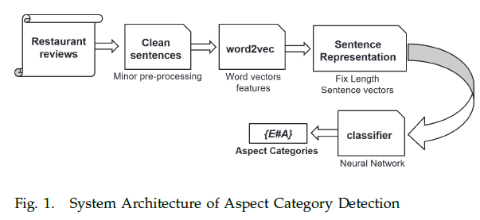

A. Sentence Representation

1) Normalized Representation of Sentence Vector:

2) Un-normalized Representation of Sentence Vector:

Input layer of the neural network takes a sentence feature vector as an input.

ReLU is preferred because 1) It has low computational cost as compared to sigmoid=tanh functions as it doesn’t require expensive operations like, calculating exponential. 2) ReLU has fast convergence rate on stochastic gradient decent as compared to sigmoid and tanh functions.

IV. TASK AND DATASET

A. English Restaurant Reviews Dataset for SE-ABSA-2016

B. Parameters and preparation of dataset

V. EXPERIMENTAL SETUP.

First restaurant review sentences are passed through a pre-processing stage. At this stage stream of tokens are generated from sentences and stop words are removed

VI. RESULTS AND DISCUSSIONS

1) Normalized representation of sentence vectors:

2) Un-Normalized representation of sentence vectors:

3) Discussion:

VIII. CONCLUSION

In this paper, we have proposed a simple and computationally less expensive method to represent a language sentence in vector spaces. Proposed sentence representation methods are divided into two categories, normalized and un-normalized sentence vector representations. Our experimental study also show that, un-normalized sentence vector representation methods always perform better than the normalized sentence vectors.